**What is a website audit?**

A website audit involves analyzing your website for technical, user experience, and SEO issues.

Some benefits of this process include finding things that may be:

* Hindering your website’s traffic potential in organic search;
* Costing you sales or conversions;
* Confusing your visitors;
* Technically unsound

## 1. Check your design

Nobody is going to trust a website that was designed in 1995.

As a general rule of thumb, it’s worth redesigning your website every 4-5 years—or at least making a few significant design updates to keep things fresh.

But this isn’t just about making things pretty or keeping up with current trends. There are quite a few things that contribute to poor website “design.”

Here are just a few of them:

### Intrusive pop-ups and ads

Pop-ups aren’t always bad. Things like exit pop-ups or cookie warnings serve a legitimate purpose.

However, there’s nothing more annoying than clicking on a web page in the Google search results, only to be hit by a myriad of pop-ups the second you land on the page.

### Illegible text

If people can’t read what’s on your website, then that’s another back button-type scenario.

So make sure to:

* **Use a large font size.** It doesn’t need to be comically large, but using an 8pt font isn’t going to fly. Not everyone has 20/20 vision… or a microscope.
* **Choose a legible font.** It’s thought that [sans-serif fonts are somewhat more readable than serif fonts](https://medium.freecodecamp.org/how-typography-determines-readability-serif-vs-sans-serif-and-how-to-combine-fonts-629a51ad8cce). Having said that, this is probably reading too much into things (no pun intended). Just avoid Comic Sans (or anything remotely similar).
* **Use enough white space**. Not enough white space makes for an unpleasant reading experience.
* **Use contrast.**Yellow text on a white background? No thanks.

### Unclear calls to action

A call-to-action prompts the visitor to do something specific.

For example, the big orange button on our old homepage that reads “Start a 7-day trial for $7” is a clear call-to-action. We’re prompting visitors to do something very specific by clicking that button.

## 2. Check your navigation

Imagine a website without a navigation bar. Finding anything you wanted would be a struggle.

That’s why it’s essential to ensure that your navigation menu not only exists but also makes sense to visitors. Even if your navigation menu seems logical to you (the person most familiar with your website), your visitors may not find it so user-friendly.

So start by heading over to your homepage and looking at your menu.

Ask yourself:

* Is it clear?
* Does it link to all my most important pages?
* Is it cluttered with unnecessary stuff?
* Have I made it easy for visitors to contact me if they have questions?

## 3. Check for mobile-friendliness

Did you know that [more than 49%](http://gs.statcounter.com/platform-market-share/desktop-mobile-tablet) of people browse the web via mobile devices?

That means the majority of your visitors are probably viewing your website on mobile.

**SIDENOTE.**

 3-4% of people browse via tablets, which is why 49% is the majority.

Furthermore, [nearly 60%](https://searchengineland.com/report-nearly-60-percent-searches-now-mobile-devices-255025) of Google searches are done on mobile—and that’s 2016 data, it’s probably even higher now.

Translation: You need a mobile-friendly website, or you’re alienating over half of your visitors.

**PRO TIP**

If you’re curious as to how many of your visitors are visiting your website via mobile, log in to [**Google Analytics**](https://analytics.google.com/analytics/web/)and go to:

*Audience > Mobile > Overview*

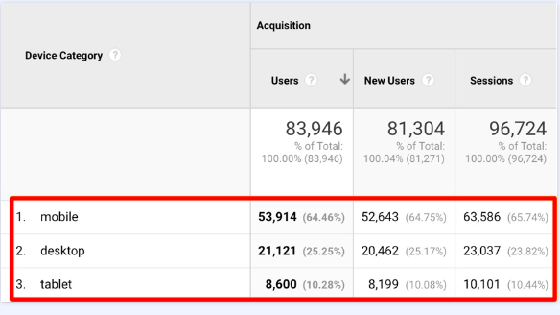

Here, you will the percentage of your visitors that come from mobile vs. desktop vs. tablet.

Check the mobile-friendliness of your website using [Google’s Mobile-Friendly Test too](https://search.google.com/test/mobile-friendly)l

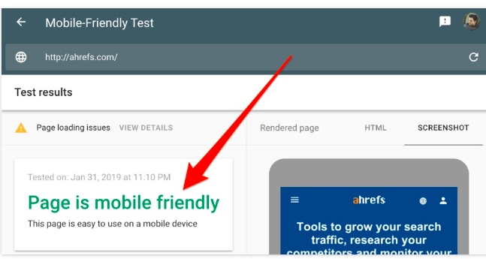

**4. Check your *robots.txt* file and sitemap**

[**Robots.txt is a simple text file**](https://ahrefs.com/blog/robots-txt/)**that tells search engines which pages they can and can’t crawl.** A sitemap is an XML file that helps search engines to understand what pages you have and how your site is structured.

If you have a robots.txt file, it’ll be accessible at *yourdomain.com/robots.txt.*

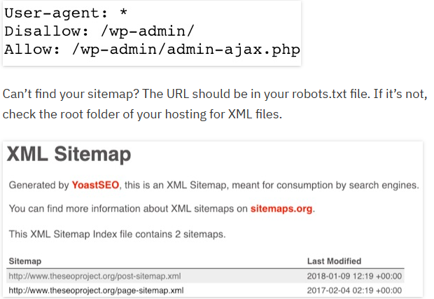

If you have a small website (under ten pages), then don’t worry too much about either of these files. However, if you’re using WordPress, you can use a plugin like [Yoast SEO](https://wordpress.org/plugins/wordpress-seo/" \t "_blank) to create both a robots.txt file and sitemap easily

**5. Check that you’re using HTTPs**

 HTTPs means that a website is secure—i.e., data transfer to and from the site is encrypted. You can tell when a website uses HTTPs because there’s a lock in the URL bar, and the URL will begin with https://:



If this isn’t the case for your website, then you don’t have an SSL certificate (i.e., HTTPs).

Why does HTTPs matter? It comes down to security, mainly. Unencrypted (non-secure) data can be intercepted and stolen.

Furthermore, HTTPs is a Google ranking factor. They [said so](https://webmasters.googleblog.com/2014/08/https-as-ranking-signal.html) back in 2014.

So HTTPs is vital if you’re:

* accepting payments on your site (an absolute must)
* collecting user data (recommended)
* trying to rank higher in Google (who isn’t!?)

If you’re not using HTTPs yet, then get an SSL certificate. It’s as simple as that.

[Lets Encrypt](https://letsencrypt.org/) is a non-profit organization that provides free SSL certificates, and it’s backed by some of the biggest players in the industry—including Google. In 2019, there is no excuse for not using HTTPs.

But even if you’ve switched to HTTPs, you may still have some related technical issues like:

* Internal links to non-HTTPs versions of a page
* Mixed content (i.e., specific files like images being loaded over HTTP and non-HTTPs, even if they’re on a secure page)
* Canonicals from HTTPs to HTTP

**6. Check that your site loads fast**

 Google [states](https://www.marketingdive.com/news/google-53-of-mobile-users-abandon-sites-that-take-over-3-seconds-to-load/426070/) that 53% of mobile visitors leave websites that take more than 3 seconds to load.

Furthermore, Amazon [found](https://blog.gigaspaces.com/amazon-found-every-100ms-of-latency-cost-them-1-in-sales/) that a slowdown of 100 milliseconds cost them 1% in sales—and that was 10+ years ago. Those numbers are likely even more mind-boggling now.

**7. Check content “quality”**

 Whether it’s a blog post or a simple “about us” page, your content should be high-quality and valuable to your visitors. That means being:

* Well-written
* Informative
* Free of spelling and grammatical errors (hint: use [Grammarly](https://www.grammarly.com/" \t "_blank) to check)
* Easy to understand (hint: use [Hemmingway](http://www.hemingwayapp.com/) or [Readable](https://readable.io/))
* Skimmable (i.e., not a giant wall of text)
* Not a duplicate of another page

If you have a relatively small site (fewer than twenty pages), you can check all of the above manually with ease. Load the pages up one-by-one and read through them. Fix any errors you come across.

For example, here’s a page that makes all kinds of basic errors:



First of all, it’s hardly skimmable. There are no images, no subheaders; it’s just a big wall of text.

You should always aim to use subheaders to break up your content and make it more appealing. In HTML, you can use H1-H6 subheaders to provide some structure and hierarchy to your pages.

Here are the basics:

* Use **one** [H1 tag](https://ahrefs.com/blog/h1-tag/) on each page for the title
* Use H2 tags for main subheaders
* Use H3 tags for sub-subheaders
* Use H4 tags for sub-sub-subheaders
* … you get the gist!

Here’s how this might play out for the page above:

* Header (H1): The Investment Mistake Otha Anders Made
  + Subheader (H2): Who is Otha Anders?
  + Subheader (H2): The mistakes Otha Anders made
    - Sub‐sub‐header (H3): Mistake #1
    - Sub‐sub‐header (H3): Mistake #2

## 8. Check for broken pages and links

Broken pages and links lead to a bad user experience.

Here’s what a visitor sees when they land on a broken page on your website or click through to a broken third-party resource:



**Broken pages** occur when a resource on your website ceases to exist. Sometimes, these resources still have [internal links](https://ahrefs.com/blog/internal-links-for-seo/) pointing to them or have backlinks from other sites.

You can find such pages in Site Audit.

Site Audit > project > Internal Pages > look for 4XX errors

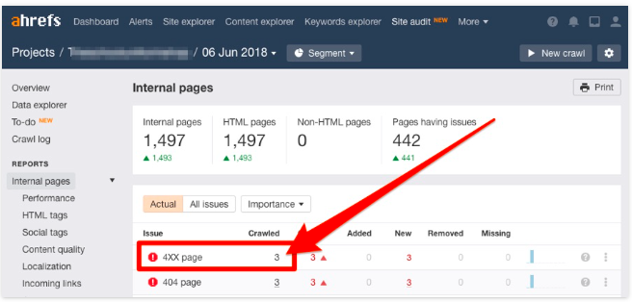

**Broken links** occur when a third-party resource to which you link ceases to exist.

You can also find such pages in Site Audit.

Site Audit > project > External Pages > look for External 4XX errors

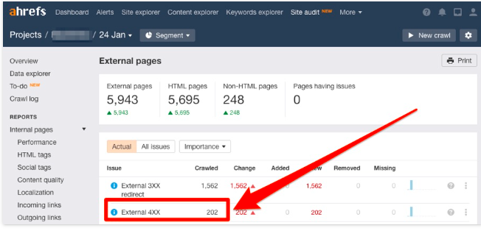

## 9. Check for unique, compelling meta titles and descriptions on every page

Every page on your website should have a unique meta title and description.

Not sure what these are? They’re HTML tags that show up in Google search results:

But before you start changing things, you first need to audit them to find:

1. Pages without any titles or descriptions
2. Pages without unique titles or descriptions
3. Pages with titles and descriptions that are too long
4. Pages with multiple titles or meta descriptions

For that, head to the HTML tags report in [Ahrefs Site Audit](https://ahrefs.com/site-audit)

Site Audit > project > Internal pages > HTML tags

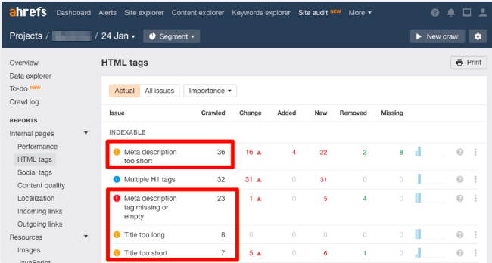

**NOT AN AHREFS USER?**

It’s not as fast, but you can use a tool like [this one](https://serpsim.com/).

Paste in your URL, and it’ll pull in the title and meta description. It also tells you if it’s too long and likely to be truncated in the search results

Neither Ahrefs nor any other tool can tell you if your titles and descriptions are compelling. You’ll have to judge that for yourself. However, if you’re a Search Console user, I’ll leave you with one final trick: Check the Performance report in Search Console for pages that get lots of impressions but a low CTR.

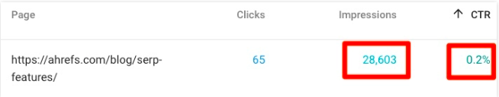

Because these pages have lots of impressions, they must be showing up for searches people are making in Google. The issue is that nobody is clicking on them, which **may** indicate a less than enticing title or meta description.